# Linux Fundamentals Part 2

# Task 1: Introduction:

# 

# Task 2: Accessing Your Linux Machine Using SSH (Deploy):

Start the machine.

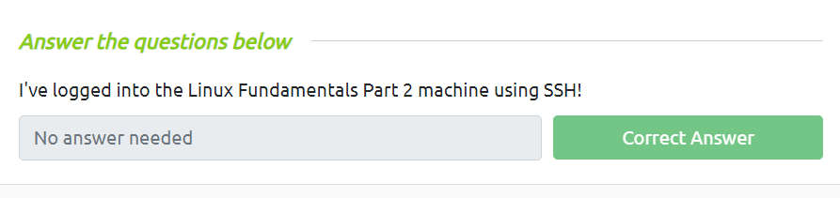

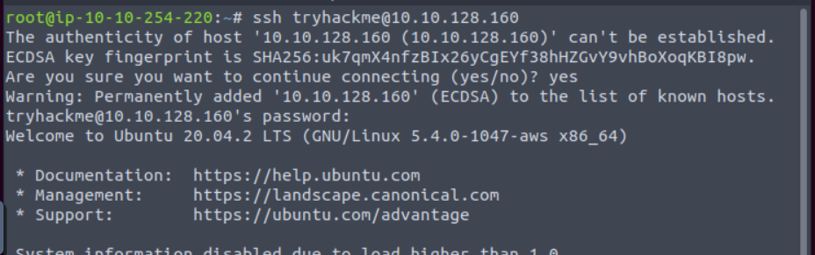

**Task 3: Introduction to Flags and Switches**

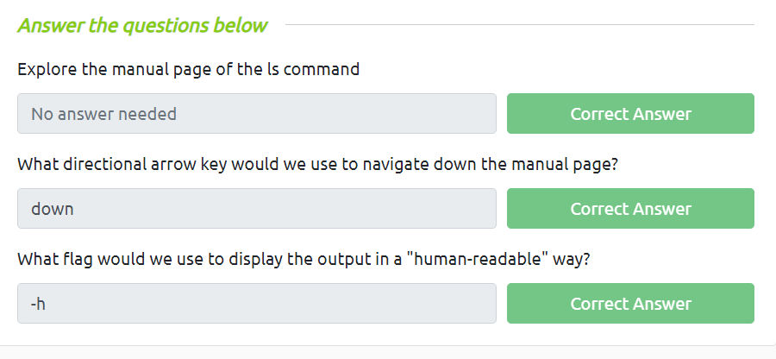



**Task 4: Filesystem Interaction Continued:**

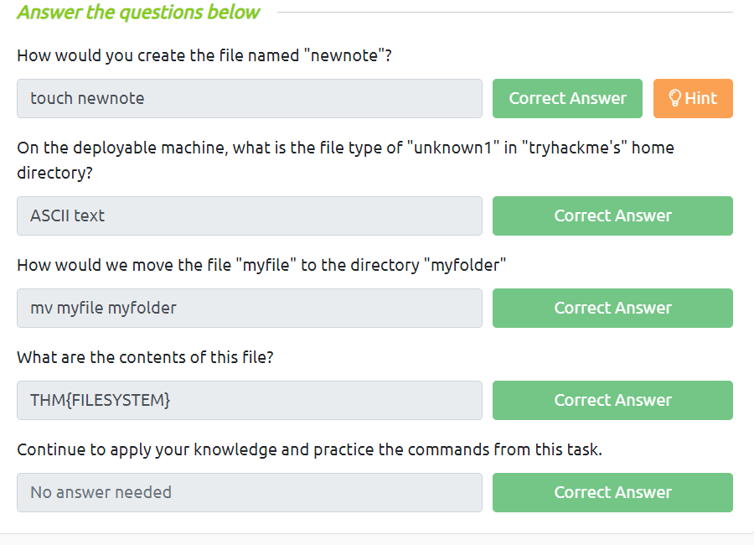

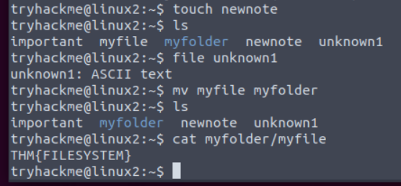

**Task 5:**  **Permissions 101**

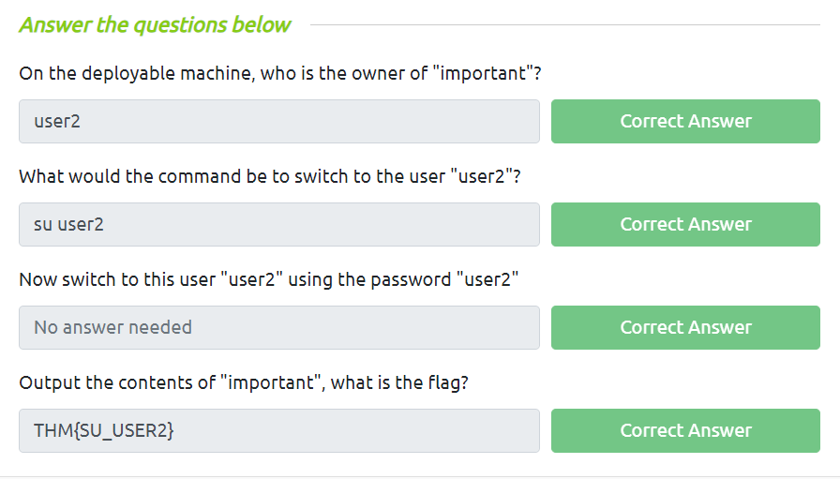

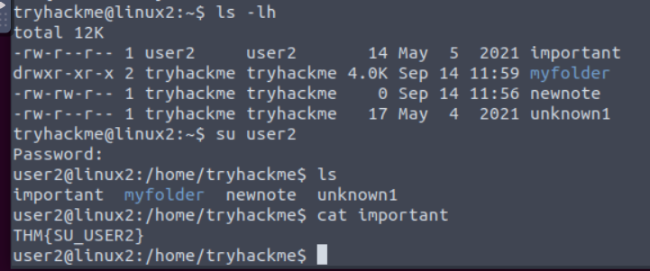

**Task 6: Common Directories:**

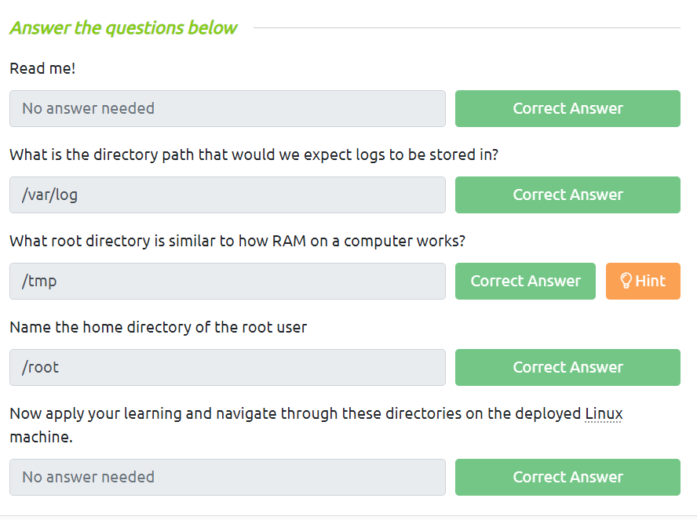

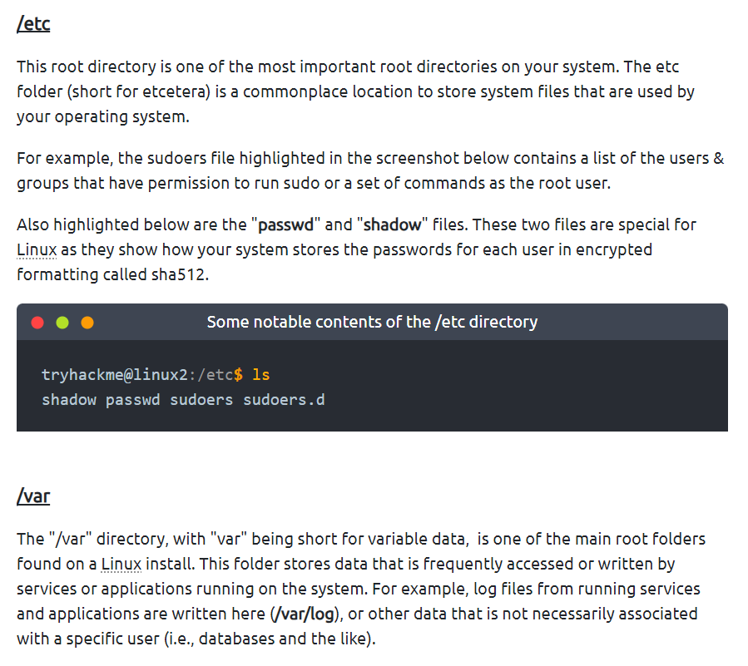

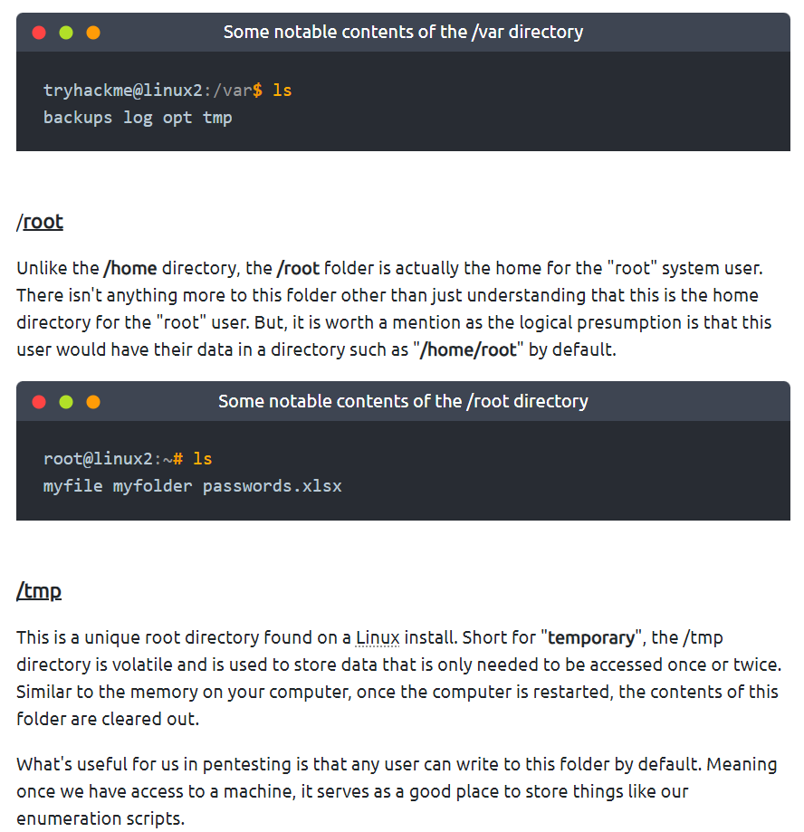

**Task 7: Conclusions and Summaries**

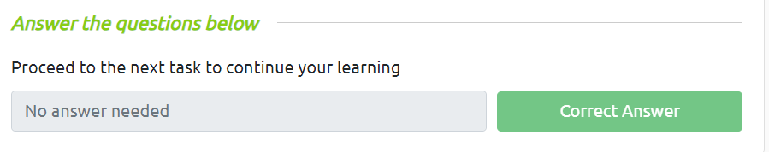

**Task 8: Linux Fundamentals Part 3**

